Subject: METHODS MAT

Investigation 2, 2015

Topic – Arithmetic and geometric sequences

Take home component- SOLUTIONS

Activity 1

Maximum height = 4.178 m
Far left: height = 1 m
Far right: height = 1.457 m
Area = 4 x 25 = 100 m²

Question 1 (a)
The number of sheets required is 15 metres ÷ 20 cm i.e. sheets

Question 1 (b)
Area of first metal sheet is

Question 1 (c)
Area of each metal sheet is m²

Question 1 (d)
The expression is the sum of a geometric sequence with t₁ = 1.1^{0.2} with r = 1.1^{0.2}, and n =75

Question 1 (e)
Area = 0.1 x 15 m = 1.5 m²

Question 1 (f)
Determine the sum of the 75 terms.
Total area = 33.655 + 1.5 = 35.155 m²

Activity 2
Width of strip is 20 cm. The function is
n = (25-15) ÷ 0.2 = 50 (50 sheets)
Using left hand values at x = 15, 15.2, 15.4, …., 24.8
Area above the ground
= 0.2×(20.3×0.9¹⁵) + 0.2×(20.3×0.9^{15.2}) +0.2×(20.3×0.9^{15.4}) +…+0.2×(20.3×0.9^{24.8})
= 0.2×20.3(0.9¹⁵+0.9^{15.2}+0.9^{15.4}+….+0.9^{24.8})
where 0.9¹⁵+0.9^{15.2}+0.9^{15.4}+….+0.9^{24.8} is a geometric series with t₁ = 0.90¹⁵, r = 0.9^{0.2} and n = 50.
Area above the ground
= 0.2×20.3×
= 26.111 m²
The area under the ground = 50×0.1×0.2 = 1 m².
Total area required for right side of the wall is 27.111 m².

The Project
(a)
Total area = 35.155 m²+27.111= 62.266 m².
Volume of titanium required = 0.002×62.266 = 0.1245 m³.
Number of grams = 0.1245×100³×4.5
= 560250 grams
≡ 560.25 kg
Minimum price at $15 kg is 560.25×$15 = $8403.75
Maximum price at $30 kg is 560.25×$15 = $16 807.50
(b)
The Council has $15 000 to spend on the memorial wall. The project seems feasible as the range of the cost varies from $8403.75 to $16 807.50.
The quantity of titanium required exceeds the minimum restriction.
(c)
If both sides of the wall were covered in titanium, the minimum cost would be $16807.50. The project is not feasible as the cost is too high.
(d) See solutions to Questions 1(d) and 1(f) and Activity 2
Subject: METHODS MAT

Investigation 2, 2015

Topic – Arithmetic and geometric sequences

Validation- SOLUTIONS

Question 1 (a)
Solution | Marking key/mathematical behaviours | Marks
(a) 1.8^{0.2} = 1.125 units  (b) 0.2 x 1.8^{0.2} = 0.225  (c) 5 ÷ 0.2 = 25  (d)  (e) | - Identifies 0.2 as the x value  - Substitutes 0.2 into f(x)  - Uses formula for rectangle  - Calculates area  - Multiplies or divides  - Determines correct number  - Expresses each term as an area  - Forms a geometric sequence  - Identifies correct values  - Substitutes variables into formula for sum of terms  - Determines sum of 25 terms | 1  1  1  1  1  1  1  1  1  2  1

Question 2 (a)
Solution
with
Marking key/mathematical behaviours | Marks
- Includes the first term  - Calculates each of the following four terms  - Expresses terms in surd form where necessary | 1  2  1

Question 2 (b)
Solution
By Pythagoras theorem
Marking key/mathematical behaviours | Marks
- Identifies the use of Pythagoras theorem  - Provides a statement of the relationship of the sides | 1  1

Question 2 (c)
Solution
Pythagoras theorem: PX =
Marking key/mathematical behaviours | Marks
- Substitutes into Pythagoras theorem  - Calculates the length of the hypotenuse | 1  1

Question 2 (d)
Solution

Construct a line, of length one unit, at right angles to the hypotenuse at point R. Join the end of the line to the central point to form the new right triangle.
Marking key/mathematical behaviours | Marks
- Constructs lines at right angles to the hypotenuse  - Draws lines of equal length  - Labels diagram  - Clarifies process used through description/ complete labelling | 1  1  1  1

Question 2 (e)
Solution
For an hypotenuse of 64 (64² = 4096) there will be 4095 triangles as the number of triangles is one less than the number of units for which the length of the hypotenuse is the square root.
Marking key/mathematical behaviours | Marks
- Identifies relationship with square of 64  - Identifies number of triangles  - Links number of triangles to square root of the hypotenuse  - Determine number of triangles | 1  1  1  1

Question 3 (a)
Solution | Marking key/mathematical behaviours |  | Marks
(i)  (ii)  (iii) | - Calculates first term  - Calculates second term  - Calculates third term |  | 1  2  2

Question 3 (b)
Solution | Marking key/mathematical behaviours | Marks
(i)  (ii) | - Copies pattern  - Extends pattern  Identifies first term  States recursion | 1  1  1  1

Question 3 (c)
Solution | Marking key/mathematical behaviours | Marks
Terms are approaching 1.618  The fraction being added each time is decreasing in value | - Identifies oscillation  - Identifies limiting number  - Identifies decreasing amount to be added to each term | 1  1  1

Question 2 (d)
Solution
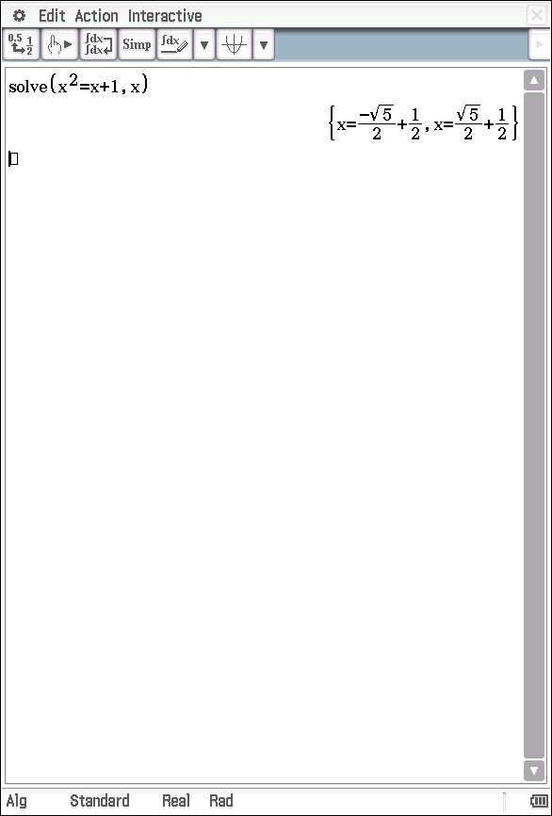

Marking key/mathematical behaviours | Marks
- Identifies two solutions  - Expresses solutions in irrational form  - Determines correct solutions for α and β | 1  1  1

